INGLÉS 5° grado AB TM y AT

GUESS THE ANIMAL

It is grey and big. It has got a long trunk. | It is small. It has got four pairs of legs.
It is a pet. It can bark. | It is brown or black. It has got a long tail. It can climb trees.
It is an insect. It is colourful. | It is a pet. It has got soft fur and small ears.
It has got a hard shell.  It can’t run fast. | It is dangerous. It can swim. It has got sharp teeth and a big mouth.
It has got a long neck and spotted skin. | It is a feIine, but it isn’t a pet. It hunts other  animals. It is light brown.

.
- Buscá en el diccionario online (Word Reference) las siguientes palabras:
- Trunk
- Bark
- Tail
- Fur
- Shell
- Sharp
- Spotted
- Hunt
- Adiviná los animales según las descripciones.

- Elegí un animal que no aparezca en las descripciones anteriores. Dibujalo y describilo brevemente.

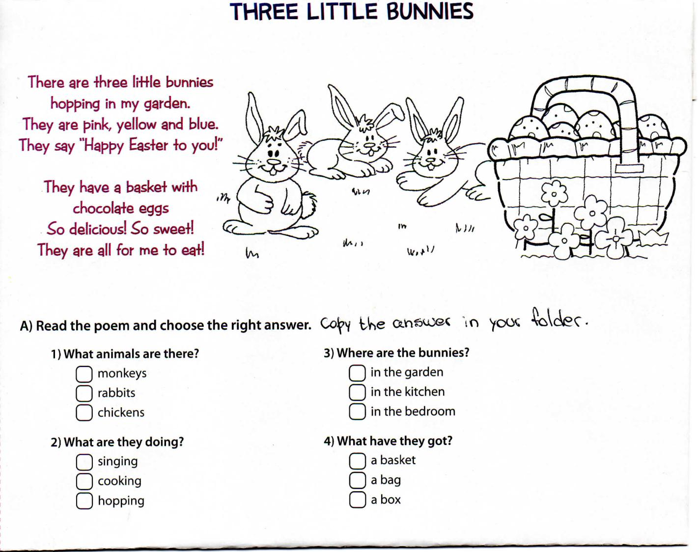
- Lee el breve texto.
- Léelo nuevamente y elegí la opción correcta.

